**EXP 10 FONT COLOUR CHANGER**

**AIM:**

To develop an application to change the font and color of the text and display toast message.

**ALGORITHM:**

• Set up the TextView, Spinner for font selection, and buttons for applying styles and choosing color.

• Load the font options into the Spinner.

• When clicked, retrieve the selected font from the Spinner.

• Change the TextView font to the chosen font.

• Open a color picker dialog when clicked.

• Let the user select a color and apply it to the TextView.

• Display a confirmation message after applying the styles.

**PROGRAM:**

**XML Layout (activity_main.xml):**

<?xml version="1.0" encoding="utf-8"?>

<LinearLayout xmlns:android="http://schemas.android.com/apk/res/android"

android:layout_width="match_parent"

android:layout_height="match_parent"

android:orientation="vertical"

android:padding="32dp"

android:gravity="center">

<!-- TextView to display the styled text -->

<TextView

android:id="@+id/styledText"

android:layout_width="wrap_content"

android:layout_height="wrap_content"

android:text="Hello, Style Me!"

android:textSize="24sp"

android:textColor="#000000"

android:layout_marginBottom="30dp"/>

<!-- Spinner for Font Selection -->

<Spinner

android:id="@+id/fontSpinner"

android:layout_width="wrap_content"

android:layout_height="wrap_content"

android:layout_marginBottom="30dp"/>

<!-- Button to Apply Style -->

<Button

android:id="@+id/applyButton"

android:layout_width="wrap_content"

android:layout_height="wrap_content"

android:text="Apply Style"

android:layout_marginBottom="30dp"/>

<!-- Button to open the Color Picker Dialog -->

<Button

android:id="@+id/colorButton"

android:layout_width="wrap_content"

android:layout_height="wrap_content"

android:text="Select Text Color"/>

</LinearLayout>

**Java Code (MainActivity.java):**

package com.example.textstylerapp;

import android.graphics.Color;

import android.os.Bundle;

import android.view.View;

import android.widget.Button;

import android.widget.Spinner;

import android.widget.TextView;

import android.widget.Toast;

import androidx.appcompat.app.AppCompatActivity;

import com.flask.colorpicker.OnColorSelectedListener;

import com.flask.colorpicker.ColorPickerDialog;

public class MainActivity extends AppCompatActivity {

private TextView styledText;

private Spinner fontSpinner;

private Button applyButton, colorButton;

@Override

protected void onCreate(Bundle savedInstanceState) {

super.onCreate(savedInstanceState);

setContentView(R.layout.activity_main);

// Initialize views

styledText = findViewById(R.id.styledText);

fontSpinner = findViewById(R.id.fontSpinner);

applyButton = findViewById(R.id.applyButton);

colorButton = findViewById(R.id.colorButton);

// Array for font options

final String[] fonts = {"Poppins", "Courier New", "Georgia", "Comic Sans MS", "Arial"};

// Create an ArrayAdapter for the spinner

ArrayAdapter<String> fontAdapter = new ArrayAdapter<>(this, android.R.layout.simple_spinner_item, fonts);

fontAdapter.setDropDownViewResource(android.R.layout.simple_spinner_dropdown_item);

fontSpinner.setAdapter(fontAdapter);

// Set button listener to apply style

applyButton.setOnClickListener(v -> applyStyle());

// Set button listener to show color picker

colorButton.setOnClickListener(v -> showColorPicker());

}

// Apply the selected font and color to the TextView

private void applyStyle() {

// Get the selected font from the spinner

String selectedFont = fontSpinner.getSelectedItem().toString();

// Apply the selected font

styledText.setTypeface(Typeface.create(selectedFont, Typeface.NORMAL));

// Show a Toast message

Toast.makeText(MainActivity.this, "Style Applied Successfully!", Toast.LENGTH_SHORT).show();

}

// Show the color picker dialog

private void showColorPicker() {

ColorPickerDialog.newBuilder()

.setDialogType(ColorPickerDialog.TYPE_PRESETS)

.setAllowCustom(true)

.setShowAlphaSlider(true)

.setColor(Color.BLACK)

.setPresets(new int[] {Color.RED, Color.GREEN, Color.BLUE, Color.YELLOW, Color.CYAN})

.setCallback(new OnColorSelectedListener() {

@Override

public void onColorSelected(int color) {

// Change the text color to the selected color

styledText.setTextColor(color);

}

})

.setAllowCustom(true)

.setShowAlphaSlider(true)

.setPresets(new int[]{Color.RED, Color.GREEN, Color.BLUE})

.setColor(Color.BLACK)

.setDialogId(0)

.setAllowCustom(true)

.setShowAlphaSlider(true)

.setShowColor(true)

.setColor(Color.BLACK)

.setPresets(new int[] { Color.RED, Color.GREEN, Color.BLUE })

.build()

.show(this);

}

}

**OUTPUT:**

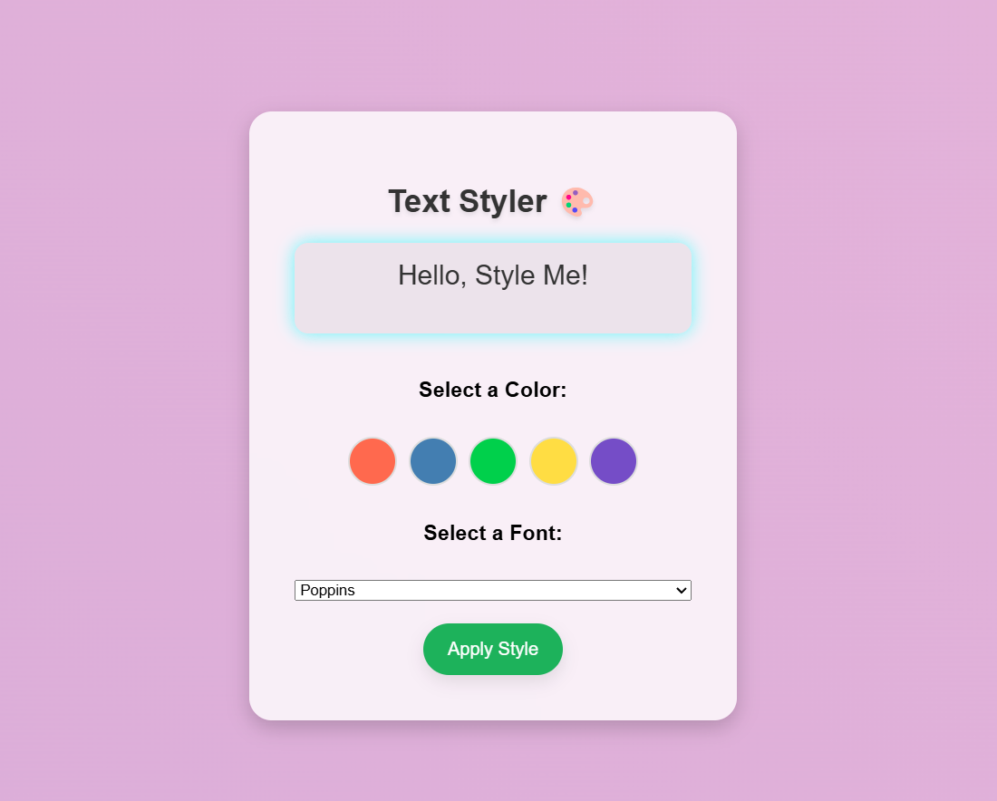

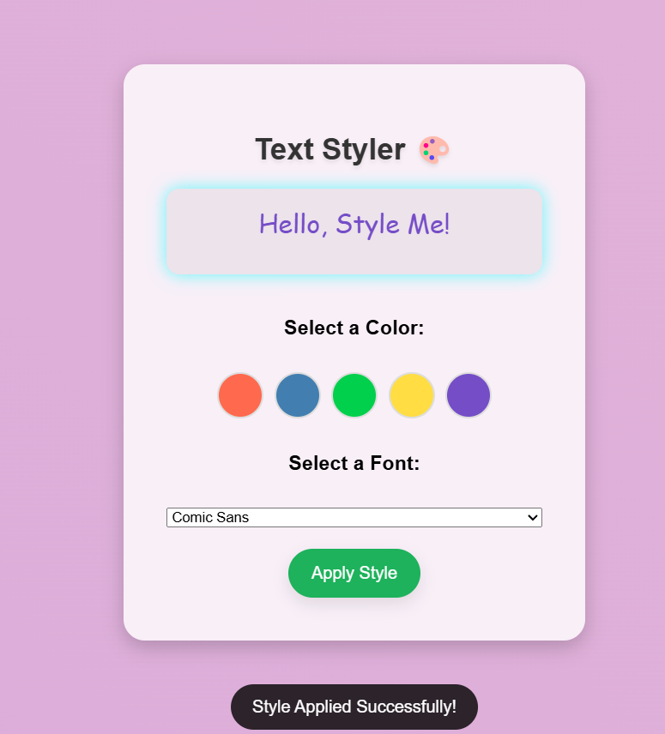

**RESULT:** Thus an application to change the font and colour of the text is developed.